

**PROJECT DOCUMENTS**

# Project Title

**Telecommunications Network Analysis**

**Team Number &** **Teammates:**

ARAVIND SAI RAM R - 720722104004

TECSON TITUS - 720722104045

PAVITHRA K - 720722104029

# Department: B.E CSE

**Year : II**

**DESCRIPTION**

Telecommunication network analysis involves the examination and evaluation of various aspects of telecommunications networks to understand their performance, efficiency, and security. This field utilizes a range of techniques, including statistical analysis, data mining, and network modeling, to extract meaningful insights and optimize network operations. Here's a detailed description of key aspects:

1. Telecommunication network analysis assesses the performance of networks by examining parameters such as bandwidth utilization, latency, packet loss, and throughput.

2. This aspect involves studying network traffic patterns, including traffic volume, flow characteristics, and protocol usage. By analyzing traffic data, operators can identify peak usage periods, detect anomalies or security threats, and plan network capacity upgrades accordingly.

3. QoS monitoring involves evaluating the performance of services delivered over the network, such as voice and video calls, streaming media, and data transfer.

4. Security is a critical aspect of telecommunications networks. Network analysis techniques are used to detect and mitigate security threats, including malware, intrusions, and denial-of-service (DoS) attacks.

5. Telecommunication network analysis helps operators optimize network design and configuration for better performance and cost-efficiency.

In summary, telecommunication network analysis plays a vital role in ensuring the reliability, efficiency, and security of modern communication networks.

By leveraging data-driven insights and advanced analytical techniques, operators can continuously improve network performance and meet the evolving needs of users and applications.

**DATA VISUVALISATION IN TELECOM NETWORK ANALYSIS**

Data visualisation is crucial in telecommunication network analysis as it helps in getting a clear idea about the relationship between different attributes in the dataset. We can draw conclusions based on these visualisations.

They can be generally done using these ways.

* 1. Pie Chart
  2. Heatmap
  3. Radar Chart
  4. Bar Chart
  5. Line Plot
  6. Bubble chart

## Code and Output

Importing packages :

import pandas as pd

import seaborn as sns

import numpy as np

import matplotlib.pyplot as plt

from math import pi

from sklearn.preprocessing import MinMaxScaler

Loading Dataset:

#loading dataset

data = pd.read_csv("/content/Telecust1.csv")

print(data.head())

Output:

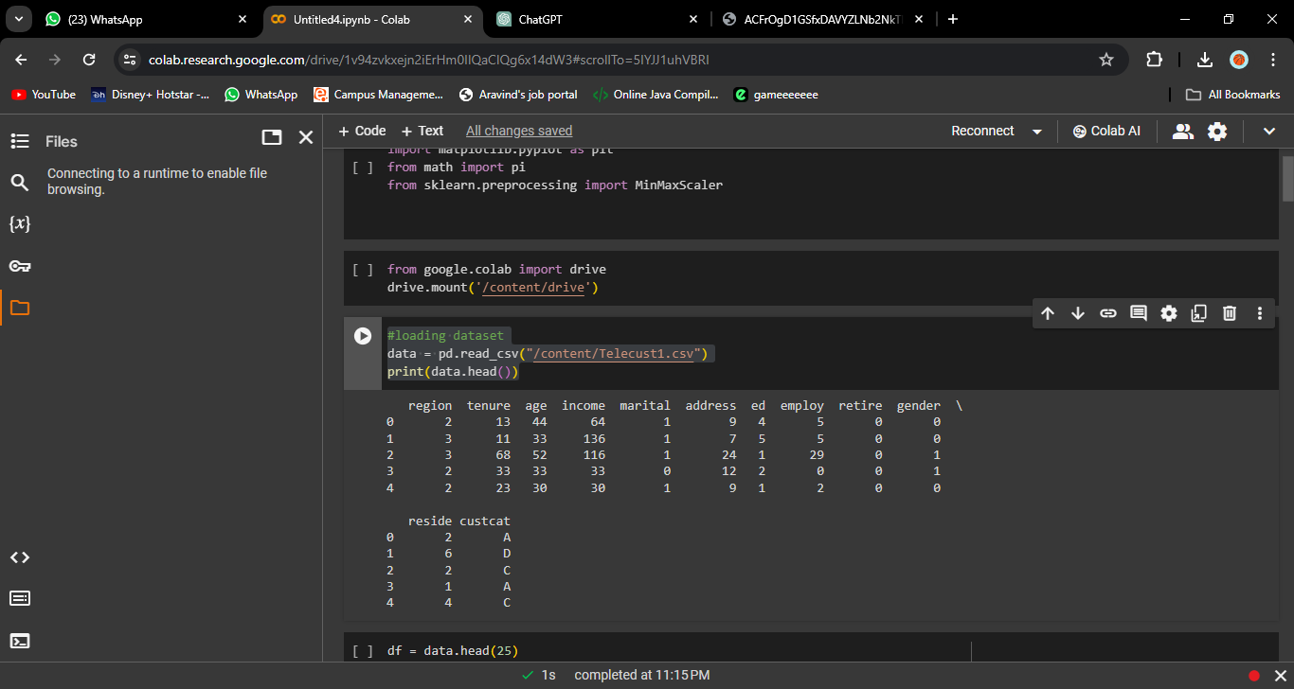

Analyze telecommunications network data for a telecom operator. (e.g., call volumes, network traffic, call drop rates)

Code:

df = data.head(25)

# Analyze telecommunications network data (e.g., call volumes, network traffic, call drop rates) for a telecom operator.

plt.figure(figsize=(10, 6))

sns.lineplot(x='region', y='income', data=df, label='cost', marker='o', linestyle='-', color='blue')

sns.lineplot(x='region', y='employ', data=df, label='employee', marker='o', linestyle='-', color='orange')

plt.title('Telecom Analysis')

plt.xlabel('Cost')

plt.ylabel('Rate')

plt.legend()

# Rotate x-axis labels for better visibility

plt.xticks(rotation=45)

plt.show()

Output:

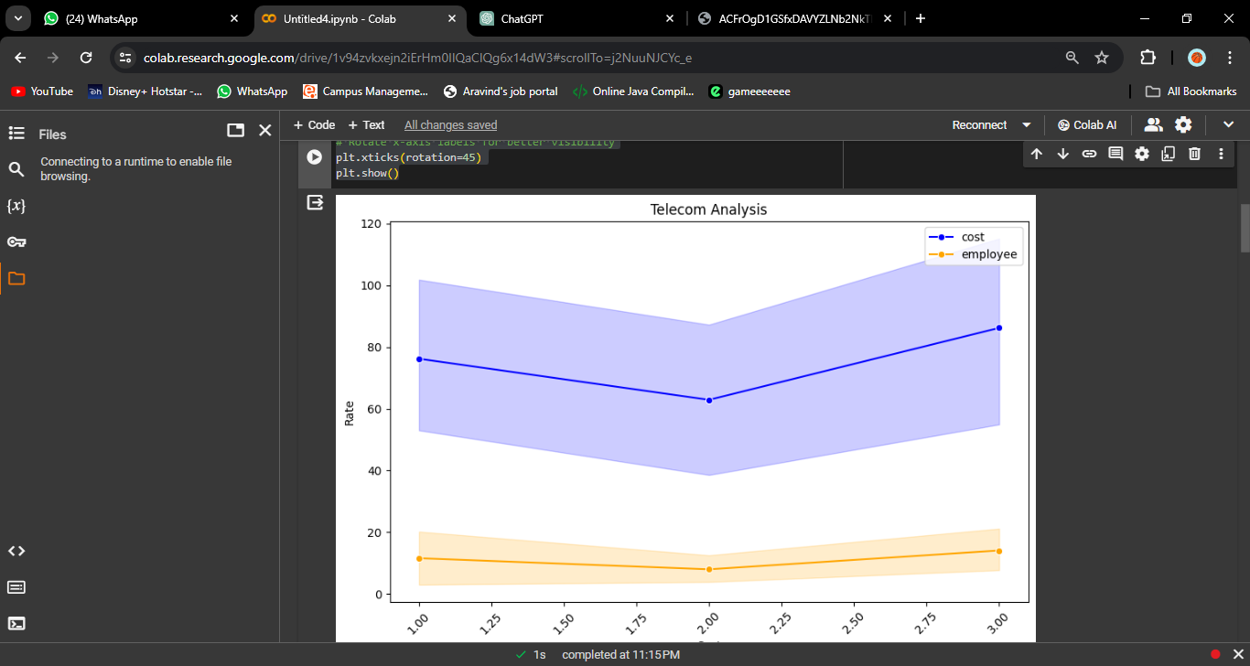

Visualize network performance using line charts, time series plots.

Code:

#Visualize network performance using line charts or time series plots.

plt.figure(figsize=(12,8))

sns.barplot(x='region',y='employ',data=df,color='blue',label='region',orient='h')

sns.barplot(x='reside',y='employ',data=df,color='orange',label='reside',orient='h')

plt.title("network performance")

plt.xlabel("Performance")

plt.ylabel("Employee")

plt.show()

Output:

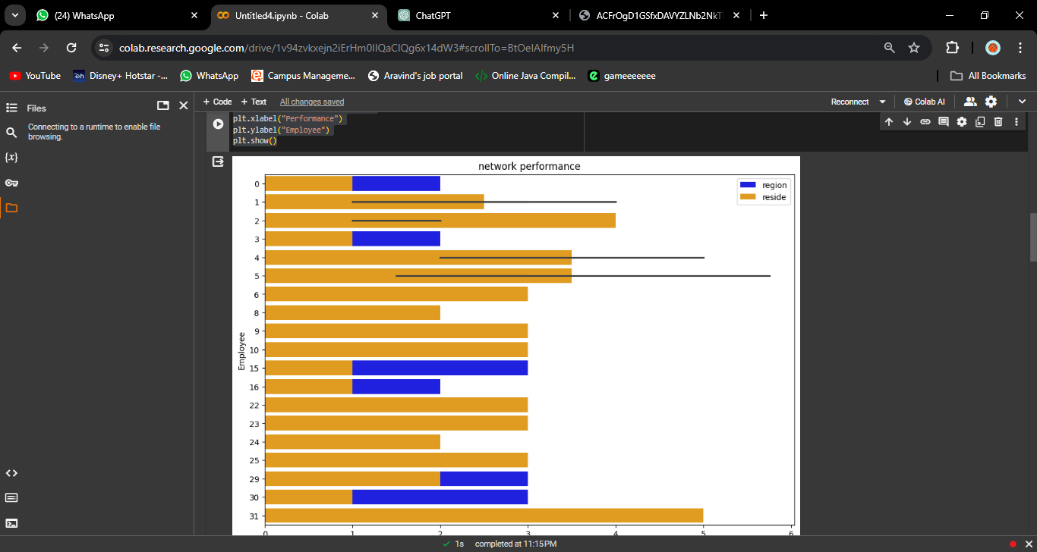

Create geographical maps to visualize network coverage and identify areas with poor signal strength.

mport folium

# Create a map centered around a specific location

mymap = folium.Map(location=[23.6850, 90.3563], zoom_start=12)

mymap = folium.Map(location=[13.0827, 80.2707], zoom_start=12)

#  Weak network coverage area

folium.Marker(location=[23.6850, 90.3563], popup='Bangladesh').add_to(mymap)

#  Strong network coverage area

folium.Marker(location=[13.0827, 80.2707], popup='Chennai').add_to(mymap)

# Display the map

mymap

Output:

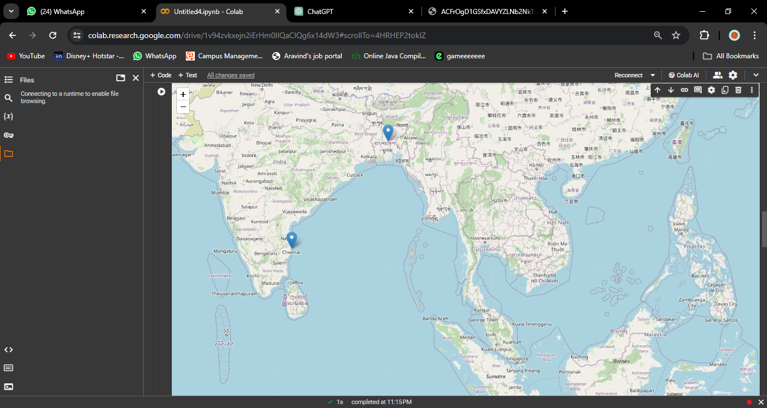

Pie Chart :

#piechart for top 10 income recieving network providers

df = data.head(10)

plt.figure(figsize=(8, 6))

plt.pie(df['income'], labels=df['address'], autopct='%1.1f%%', startangle=90,

        colors=['gold', 'orange', 'lightblue', 'lightgreen', 'pink','red','yellow','bisque','darkblue','brown'])

plt.title('Top 10 network providers address code')

plt.show()

Output:

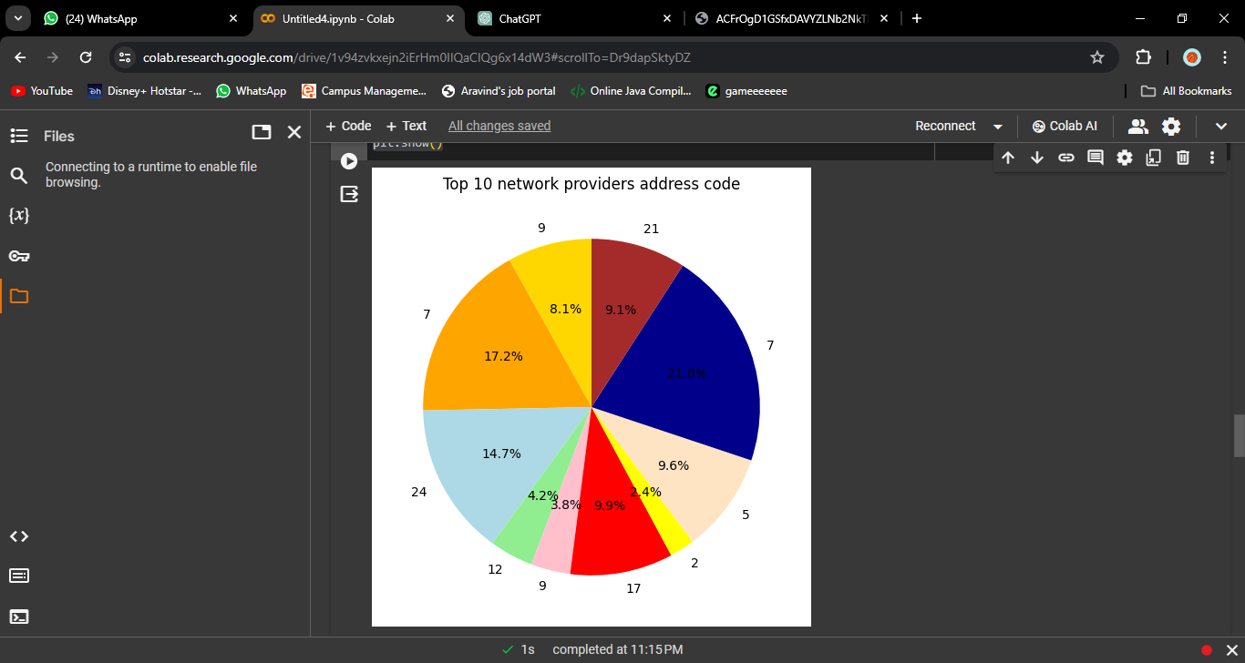

Heat Map:

Age = input('Enter the  age of the provider :')

reside = {

    'Yr': [Age] * 100,

    'x': np.random.randint(0, 101, 100),  # x-coordinates

    'y': np.random.randint(0, 101, 100)   # y-coordinates

}

df_service = pd.DataFrame(reside)

# Create a heatmap for average network distribution regarding their age

plt.figure(figsize=(10, 6))

sns.kdeplot(data=df_service, x='x', y='y', cmap='coolwarm', fill=True, thresh=0.05)

plt.title(Age+'  aged Service Distribution Heatmap')

plt.xlabel('Broadband coverage')

plt.ylabel('Cost per unit')

plt.show()

Output:

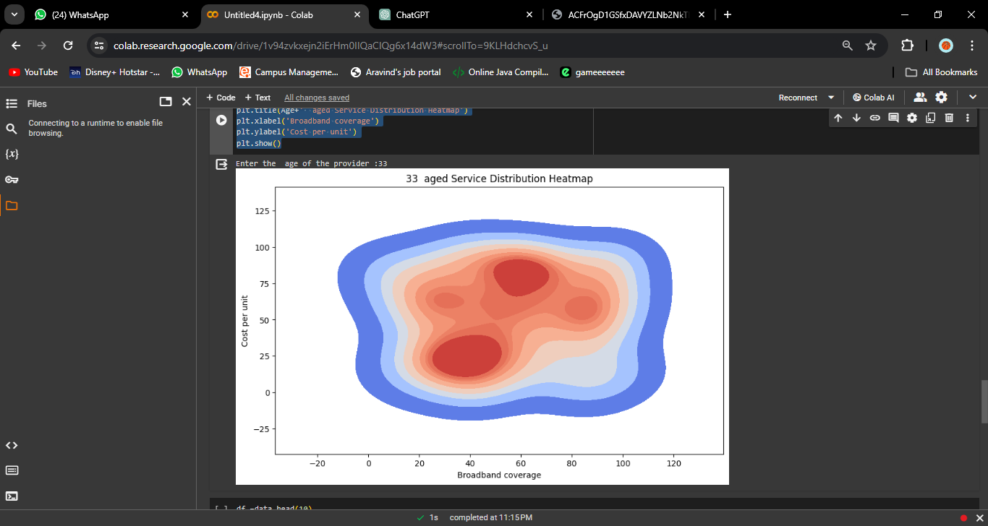

Bubble Chart:

df =data.head(10)

plt.figure(figsize=(12, 8))

plt.scatter(x=df['address'], y=df['employ'], s=df['age'] * 10,

            c=['red','green','black','orange','pink','brown','purple',

               'cyan','gray','teal'],alpha=0.5)

plt.title("Top 10 Network providers --- their location and employement")

plt.xlabel("Address code")

plt.ylabel("employement rate")

plt.show()

Output:

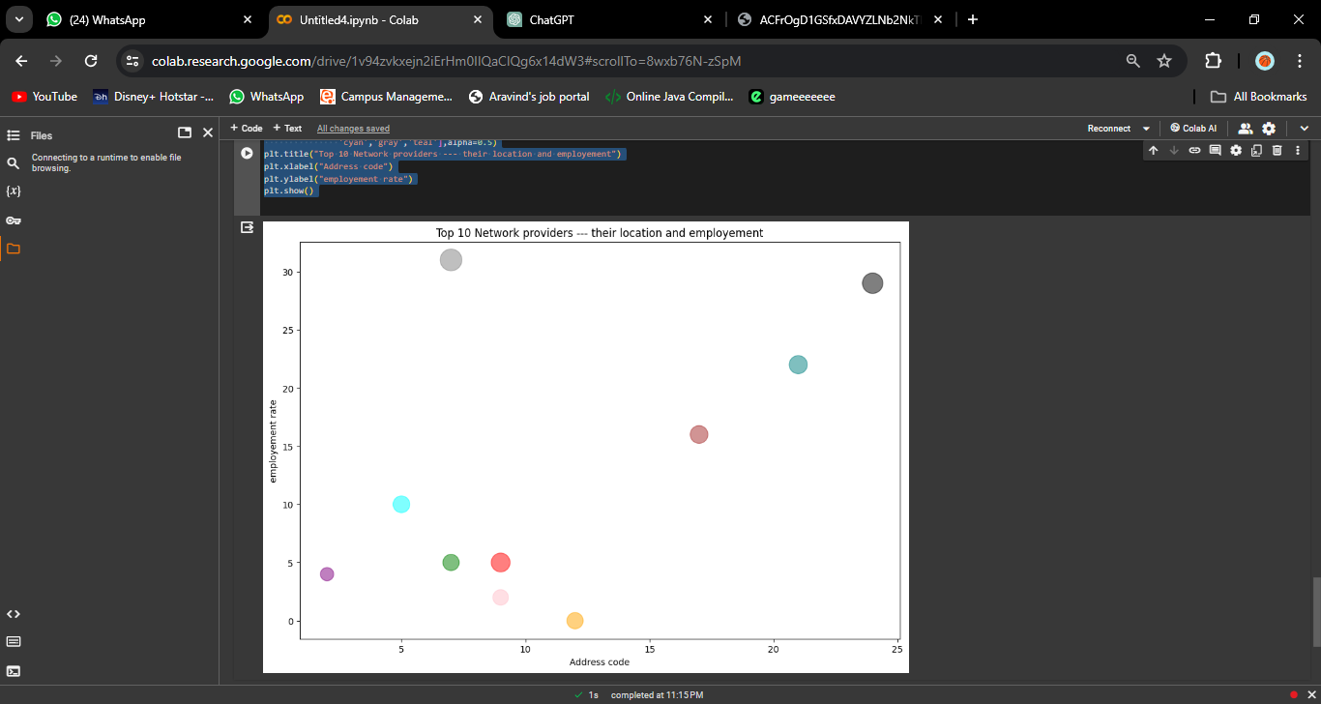

**Github Link :**

https://github.com/aravindsairam2004/dv-project.git